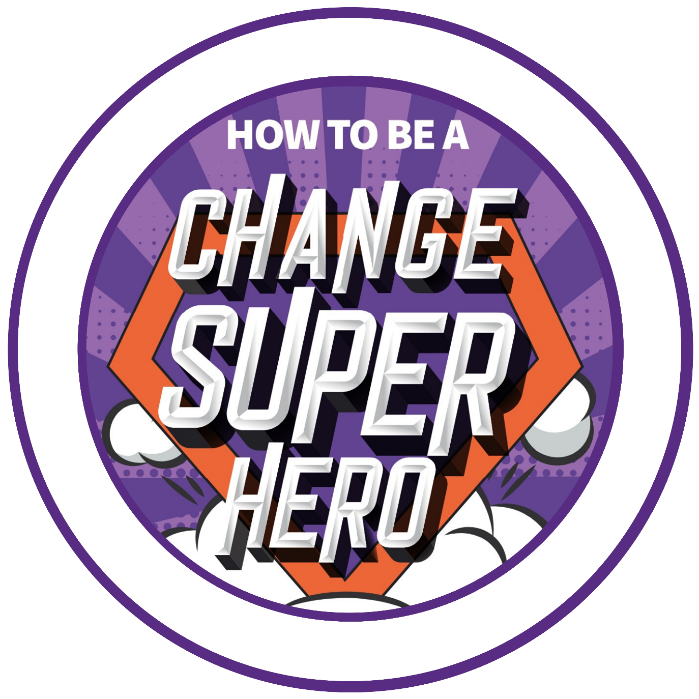
Change Superhero Toolkit: Factsheet Template

Factsheet Template
Instructions: this document should be no longer than two pages and written avoiding technical jargon so that anyone can pick it up and understand what your project is about.

What is the Project?
Write answer – simple summary of what the project is

Why do we need the system?
Write answer – what is the case for change?

What does success look like?
Write answer – what is the vision for the future?

How does this fit with other on-going programmes and projects?
Write answer – this may not be relevant for your company

What and who is in scope?
Write answer – who are your stakeholders: both internal and external?

When is it happening?
Write answer – high level timeline & implementation plan

Where can I find out more information?
Write answer – include names and what part of the project they are responsible for

