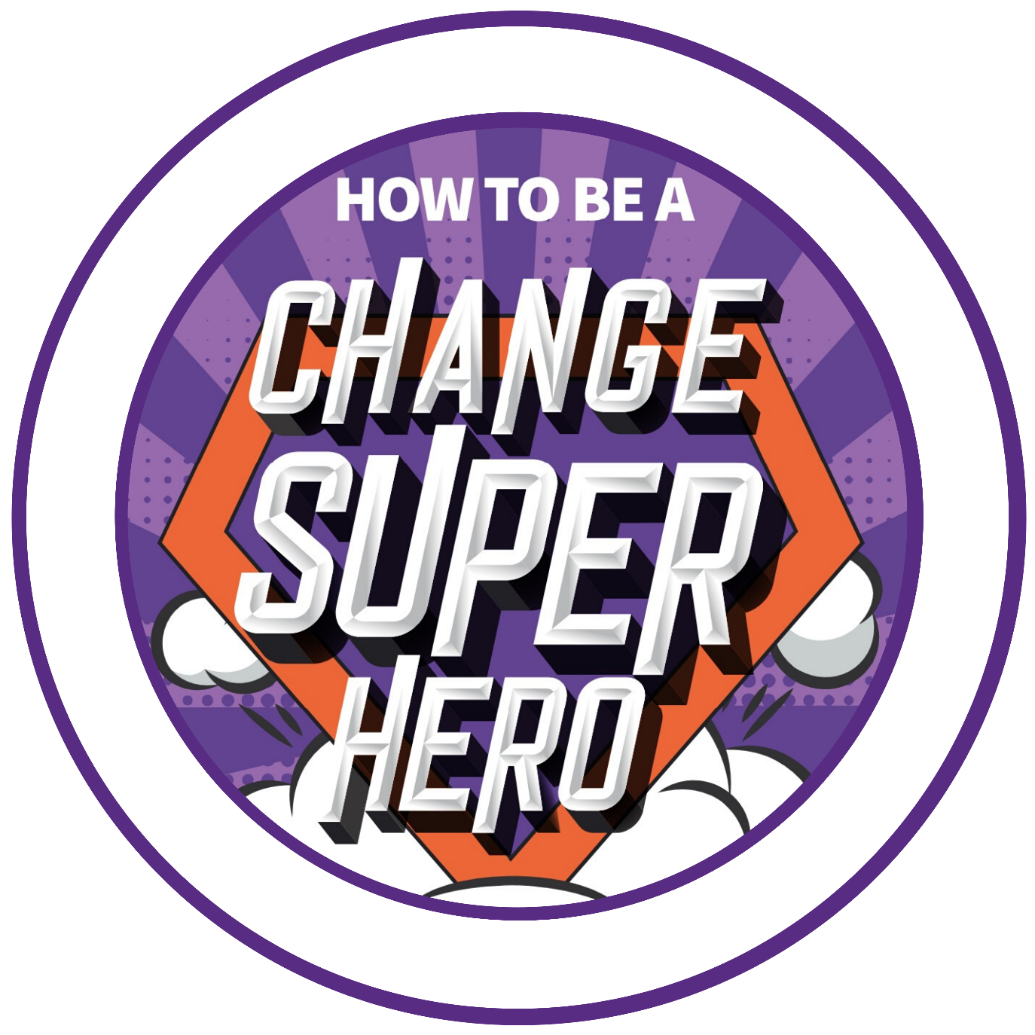
Change Superhero Toolkit:
Cultural Web Template

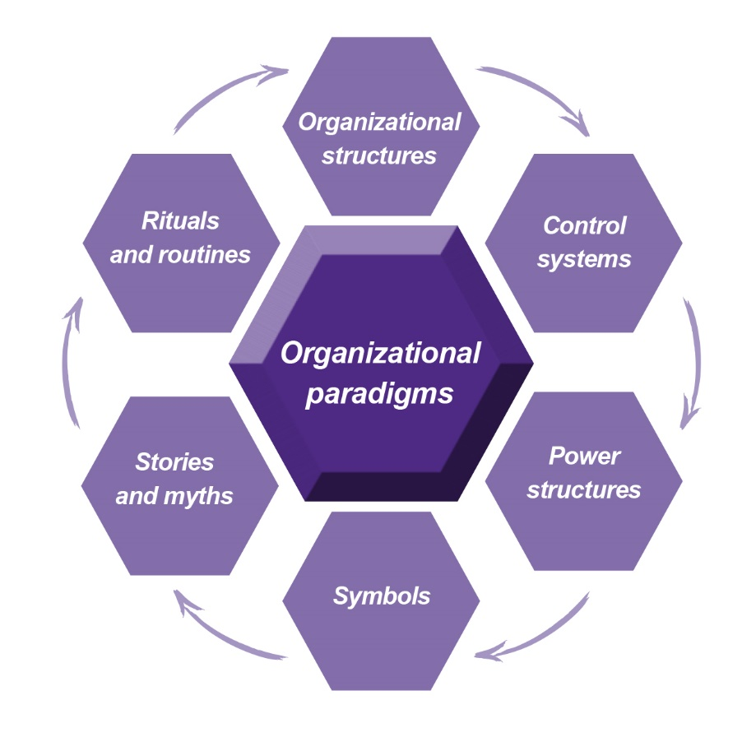
Cultural Web Template

- Organisational Structures – This is the hierarchy of the organisation and will illustrate where the power lies, how decisions are made and where communication flows.
- Control Systems – Systems and mechanisms that report on and control the organisation. What we measure tends to drive behaviour.
- Power Structures – These are the people and systems that who have power and influence and can get things done, with both formal positional power and informal personal power.
- Symbols – Official and unofficial visual representations of culture e.g. Logo’s, Offices, Uniforms.
- Rituals and Routines – The habitual activities, norms and ways of working.
- Stories and Myths – Past events and stories about the people and organisation that continue to be shared both internally and externally.

What is nice about this model is the way in which we can use this model to analyse our current culture: the ‘As Is’ and to help define the ‘To be’. This helps provide clarity about the required change both structural and cultural which helps us decide what changes need to be made to embed it.

Cultural Web Example:
 | As Is | To Be
Organisational Paradigm | Financially stable, trustworthy, quality and research driven. | Innovative, responsive, customer focused.
Organisational Structures | Hierarchical roles with formal reporting into a parent company. | Matrix or Team based structures focused around market requirements.
Control Systems | Board of Directors and Non-Execs make decisions. Formal annual cycles of budgeting, headcount and objective cascade. | Disseminated decision making and financial controls. Business case driven resourcing and budgeting.
Power Structures | CEO & F.D. and influence of parent company. | Individual empowerment and accountability. Local team leaders and managers.
Symbols | Traditional Brand and Logo, Parking spaces for top execs, Status related to size of office and formal business attire at work. | Open plan building; hot desks. ‘Chill out zones’, Online collaboration tools.
Rituals and Routines | Annual business planning, Board meetings, Sales conferences; Annual report, Long service awards. | Team huddles, weekly 121’s, Informal skype chats, Fish and Chip Friday.
Stories and Myths | The F.D. values the company car fleet above people, Gossip about executive board, Board meetings never finish on time. | Reward and recognition linked to customer impact. Innovation suggestion schemes. Individual success stories.

Blank Cultural Web Template:
 | As Is | To Be
Organisational Paradigm
Organisational Structures
Control Systems
Power Structures
Symbols
Rituals and Routines
Stories and Myths

